ultramirinc.champs_mood.fragments

Class MyViewHolderFriend

java.lang.Object

android.support.v7.widget.RecyclerView.ViewHolder ultramirinc.champs_mood.fragments.MyViewHolderFriend



public class MyViewHolderFriend

extends android.support.v7.widget.RecyclerView.ViewHolder

Created by William on 2017­04­04. This class assigns a given value to a View object, allowing the user to see the information for a given friend

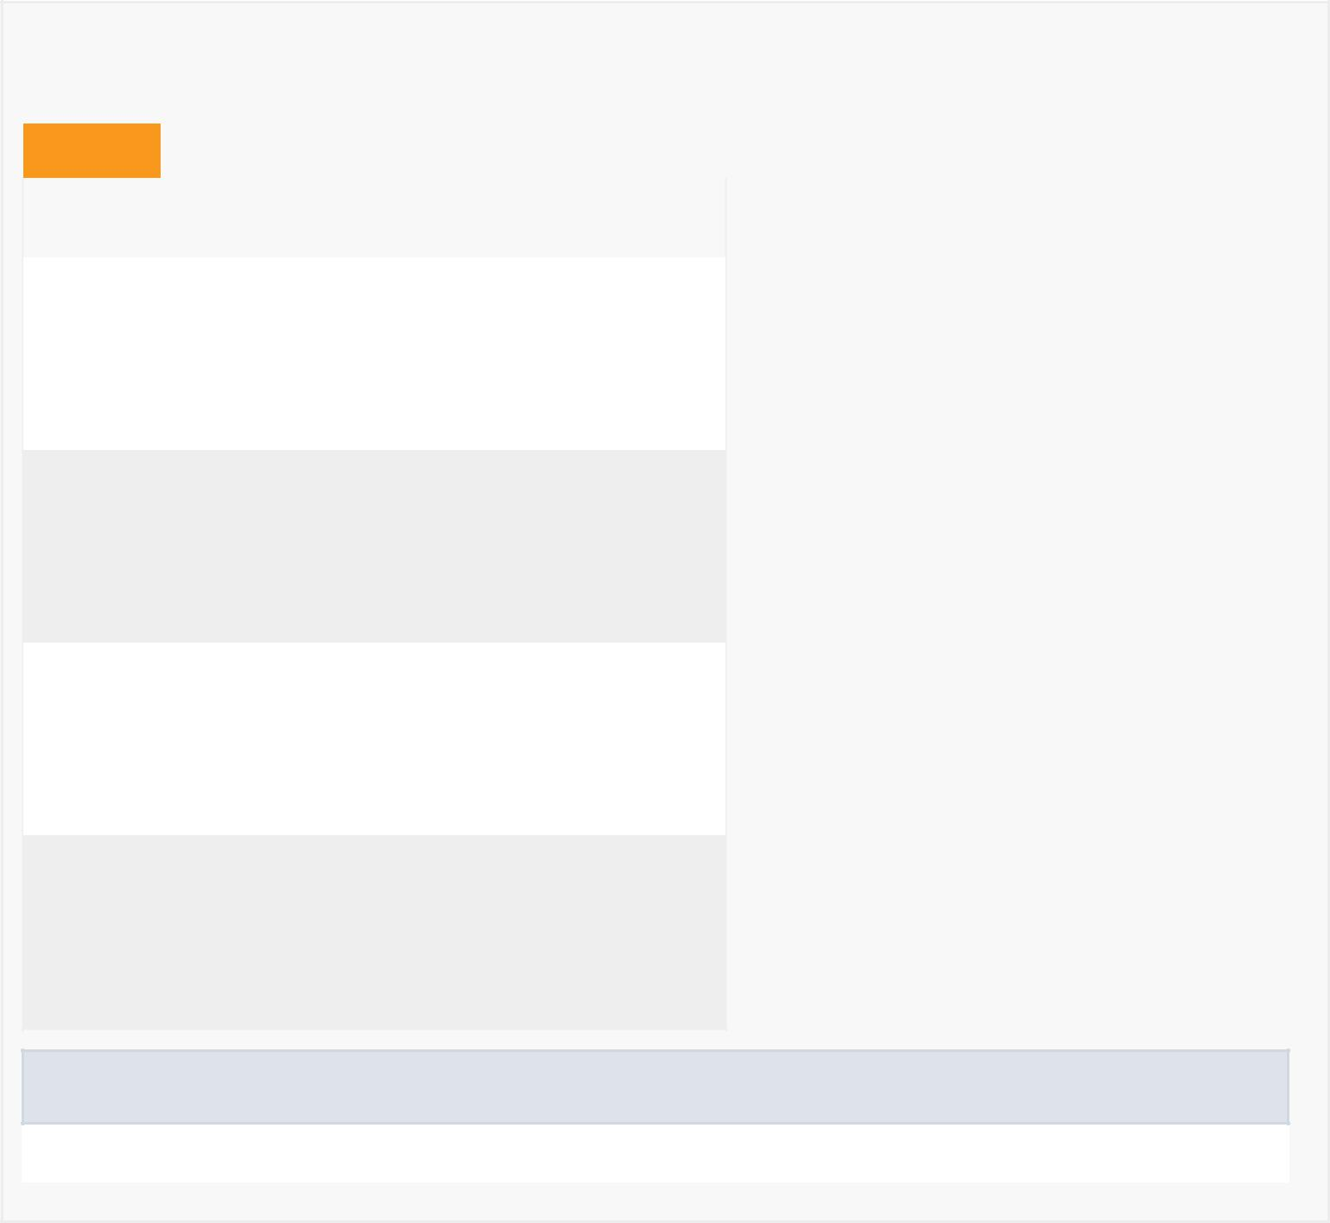

*Field Summary*

Fields

|  |  |
| --- | --- |
| Modifier and Type | Field and |
|  | Description |

private android.widget.TextView breakTextView

Contains the TextView of the friend's break text

private android.widget.Button mButton

Contains the Button of the friend's poke button

private android.widget.TextView moodView

Contains the TextView of the friend's mood

private android.widget.TextView nameView

Contains the TextView of the friend's name

Fields inherited from class android.support.v7.widget.RecyclerView.ViewHolder

itemView



*Constructor Summary*

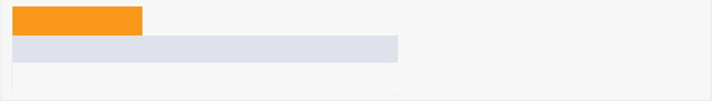Constructors

Constructor and Description

MyViewHolderFriend(android.view.View itemView)

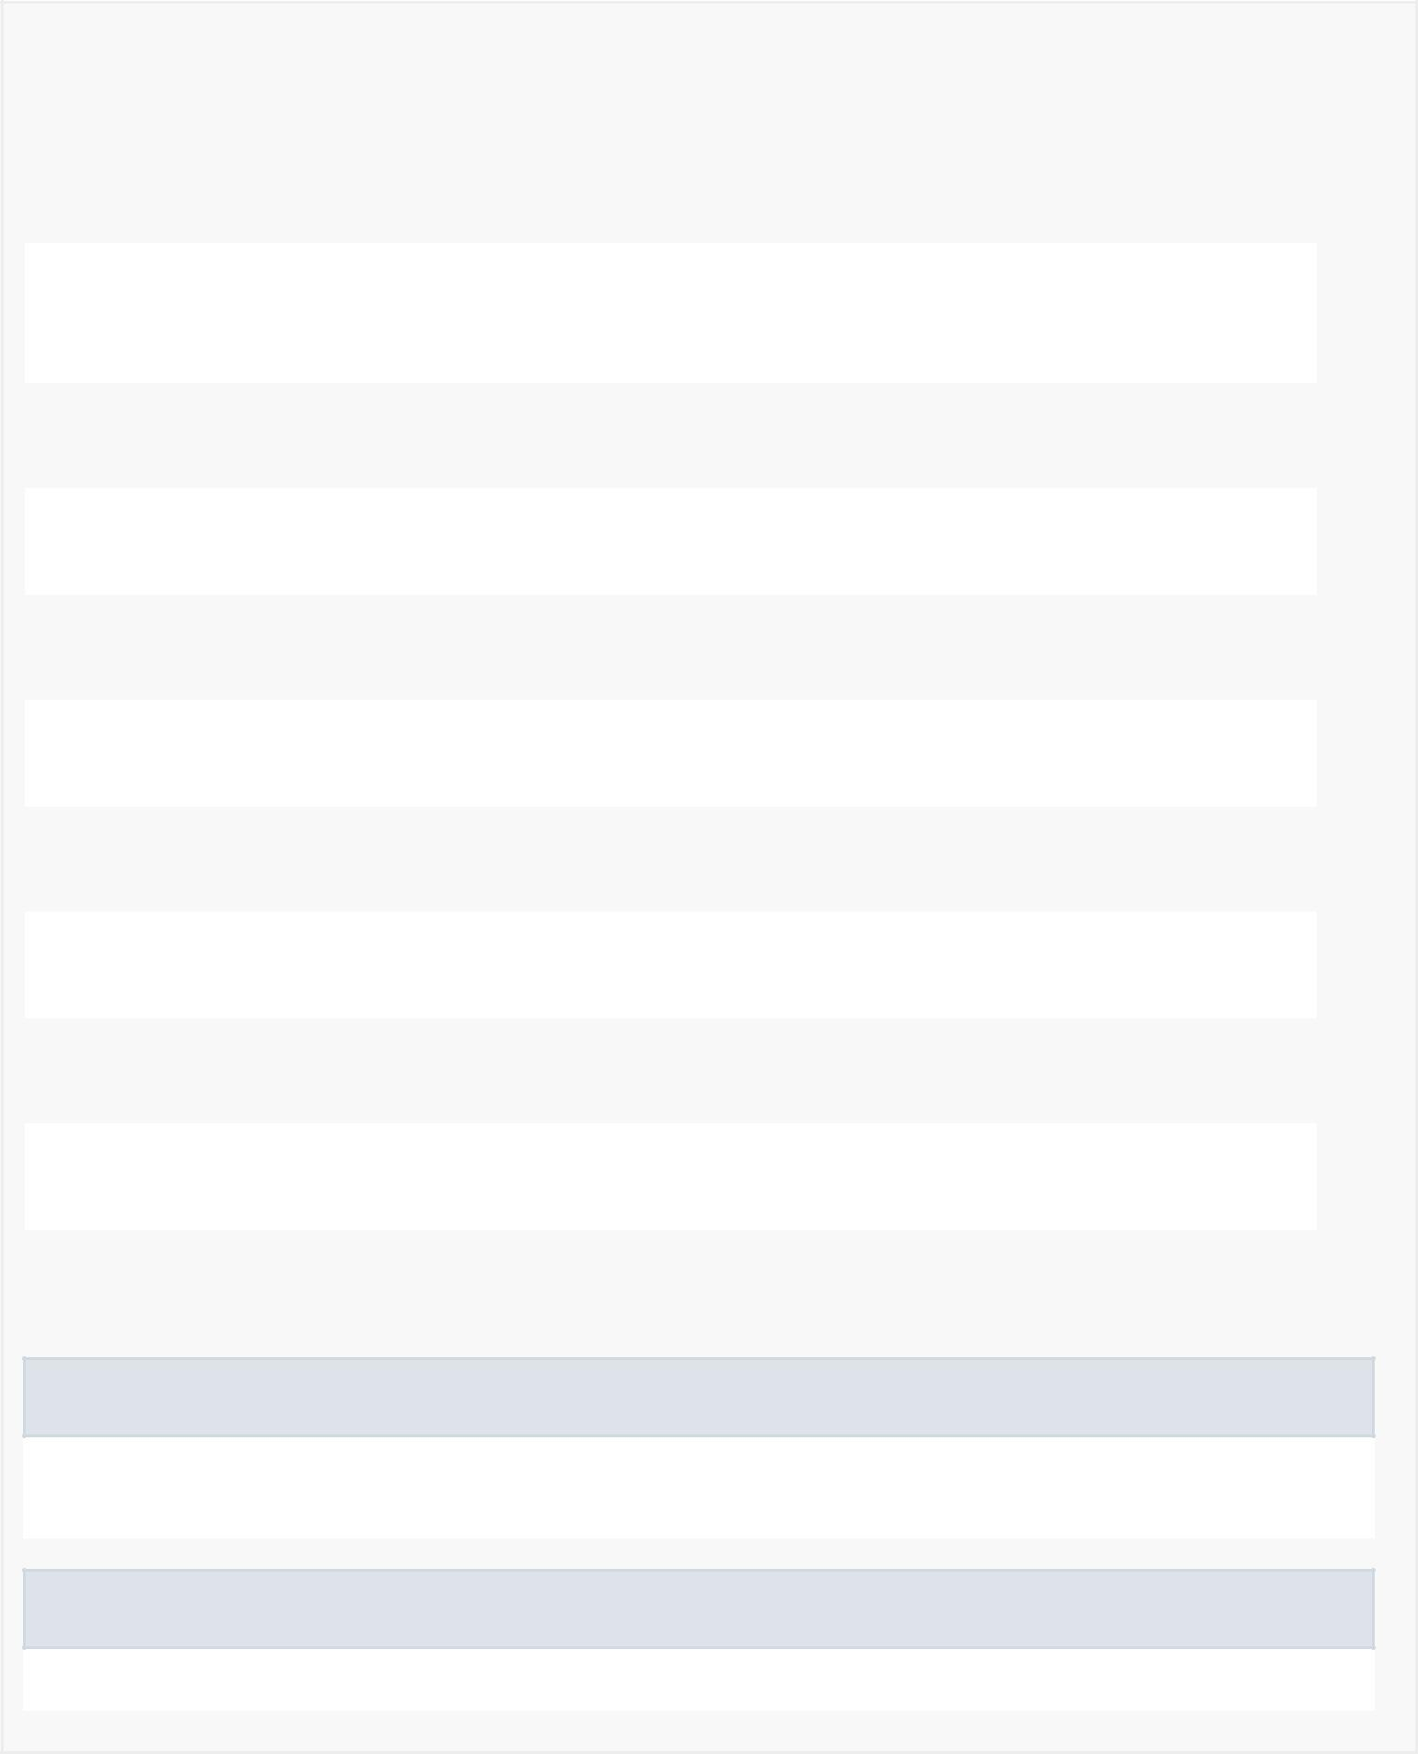

|  |  |  |  |  |  |  |  |  |  |
| --- | --- | --- | --- | --- | --- | --- | --- | --- | --- |
| *Method Summary* | | | | |  |  |  |  |  |
|  |  | |  |  | |  |  |  |  |
|  | All Methods |  |  | [Instance Methods](javascript:show(2);) | |  |  | [Concrete Methods](javascript:show(8);) |  |
|  | Modifier and Type | | |  | Method and Description | | | | |
|  | void | | |  | bind(User myFriend) | | | | |
|  |  |  |  |  | Binds the friend's name and mood to their respective TextView | | | | |
|  |  |  |  |  | variables. | | |  |  |
|  |  |  |  | |  |  |  | |  |
|  | android.widget.TextView | | | | getBreakTextView() | | | | |
|  |  |  |  |  | Getter for breakTextView. | | | | |
|  | android.widget.Button | | | | getButton() | | |  |  |
|  |  |  |  |  | Getter for mButton. | | | | |
|  |  |  |  | |  |  |  | |  |
|  | android.widget.TextView | | | | getMoodView() | | | | |
|  |  |  |  |  | Getter for moodView. | | | | |
|  | android.widget.TextView | | | | getNameView() | | | | |
|  |  |  |  |  | Getter for nameView. | | | | |
|  |  |  |  |  |  |  |  | |  |
|  | void | | |  | setBreakTextText(java.lang.String s) | | | | |
|  |  |  |  |  | Setter for breakTextView using a String variable. | | | | |
|  | void | | |  | setBreakTextView(android.widget.TextView breakTextView) | | | | |
|  |  |  |  |  | Setter for breakTextView using a TextView variable. | | | | |
|  |  |  |  |  |  |  |  | |  |
|  | void | | |  | setButton(android.widget.Button mButton) | | | | |
|  |  |  |  |  | Setter for mButton. | | | | |
|  | void | | |  | setMoodView(android.widget.TextView moodView) | | | | |
|  |  |  |  |  | Setter for moodView. | | | | |
|  |  |  |  |  |  |  |  | |  |
|  | void | | |  | setNameView(android.widget.TextView nameView) | | | | |
|  |  |  |  |  | Setter for nameView. | | | | |
|  |  |  |  |  |  |  |  |  |  |

Methods inherited from class android.support.v7.widget.RecyclerView.ViewHolder

getAdapterPosition, getItemId, getItemViewType, getLayoutPosition, getOldPosition, getPosition, isRecyclable, setIsRecyclable, toString

Methods inherited from class java.lang.Object

clone, equals, finalize, getClass, hashCode, notify, notifyAll, wait, wait, wait



*Field Detail*



nameView

private android.widget.TextView nameView

Contains the TextView of the friend's name

moodView

private android.widget.TextView moodView

Contains the TextView of the friend's mood

breakTextView

private android.widget.TextView breakTextView

Contains the TextView of the friend's break text

mButton

private android.widget.Button mButton

Contains the Button of the friend's poke button

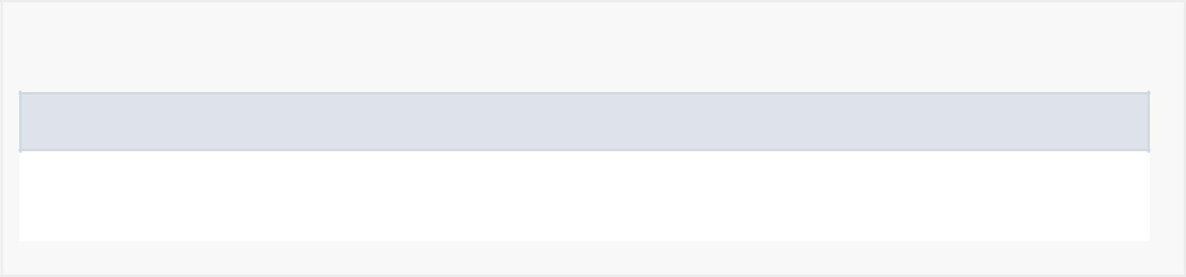

*Constructor Detail*

MyViewHolderFriend

public MyViewHolderFriend(android.view.View itemView)

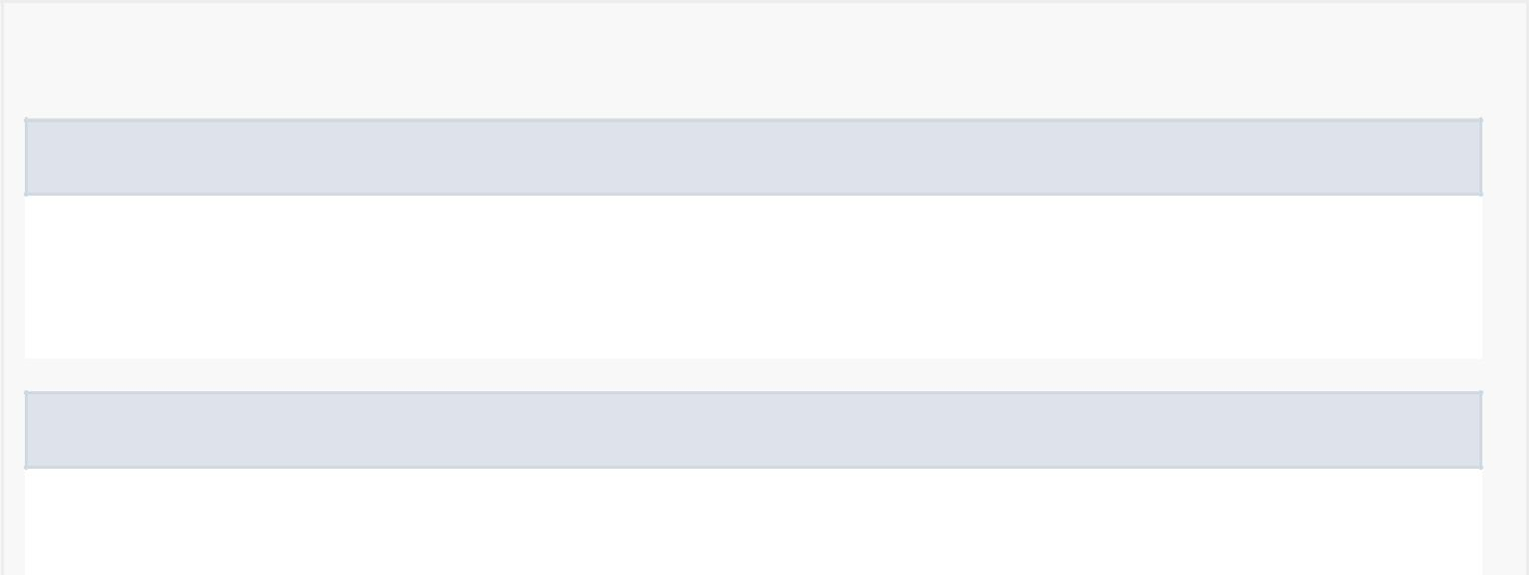

*Method Detail*

bind

public void bind(User myFriend)

Binds the friend's name and mood to their respective TextView variables.

getNameView

public android.widget.TextView getNameView()

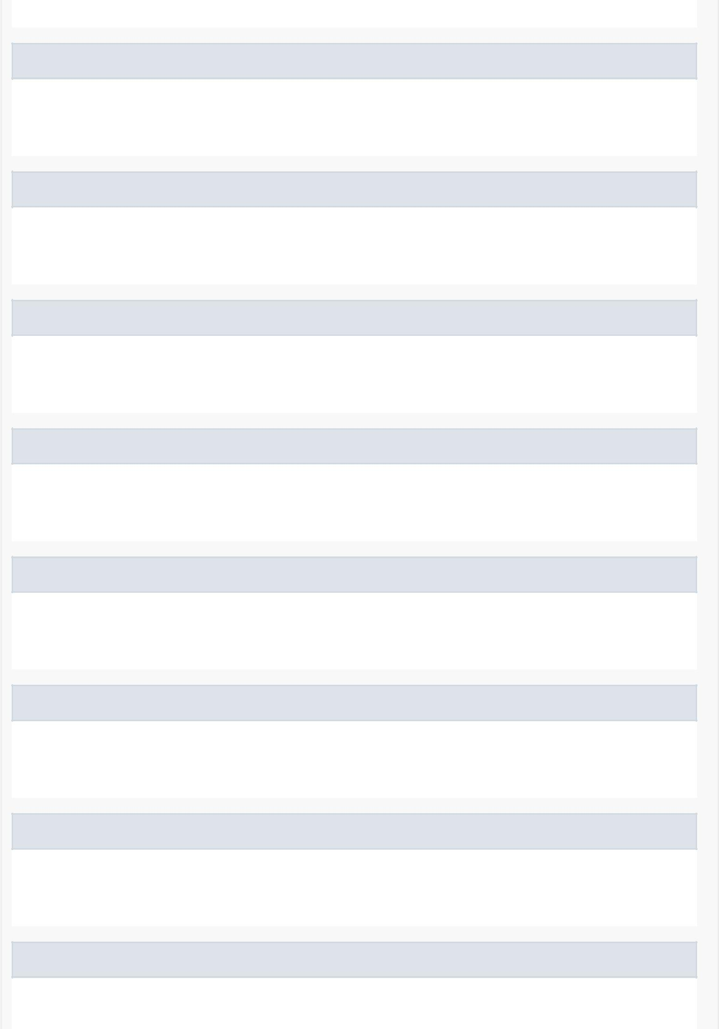Getter for nameView.

setNameView

public void setNameView(android.widget.TextView nameView)

Setter for nameView.

getMoodView

public android.widget.TextView getMoodView()

Getter for moodView.

setMoodView

public void setMoodView(android.widget.TextView moodView)

Setter for moodView.

getBreakTextView

public android.widget.TextView getBreakTextView()

Getter for breakTextView.

setBreakTextView

public void setBreakTextView(android.widget.TextView breakTextView)

Setter for breakTextView using a TextView variable.

setBreakTextText

public void setBreakTextText(java.lang.String s)

Setter for breakTextView using a String variable.

getButton

public android.widget.Button getButton()

Getter for mButton.

setButton

public void setButton(android.widget.Button mButton)

Setter for mButton.